Data Source: [Tableau Superstore](https://community.tableau.com/docs/DOC-1236)

GitHub: **https://github.com/sjanemanning/Project2**

Our group is using the Tableau Superstore dataset. Because we are moving into Tableau in the coming weeks, we thought it would be interesting to compare data visualization in Tableau vs. JavaScript. The data set consists of a list of orders, returns, and people. There are many interesting variables to compare by geography and volume.

We plan to use SQL Alchemy to populate a PostgreSQL database. From there we will use SQL to customize views and groupings of our data. Once we have cleaned the data, we will use python to pull in the results. The results will then be used in our JavaScript code. We plan to utilize the Plotly and Mapbox libraries to create interactive visualizations as well as HTML/CSS and Bootstrap. The final product will be deployed in a flask app.

The Visualizations will toggle 3 charts displaying geography, product, and ship date as they relate to profIt and returns.

We are drawing inspiration from the below Tableau Visualizations and our Metrics will be ‘profit’ and ‘returns’

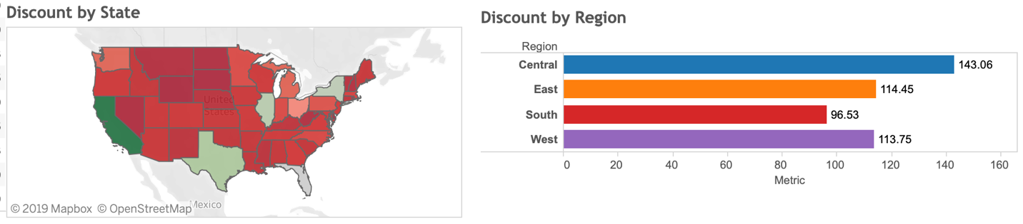

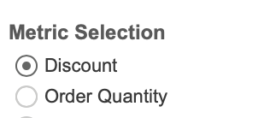

Screenshot of Data Source

